The Nautilus DevOps Team has received a new request from the Development Team to set up a new EC2 instance. This instance will be used to host a new application that requires a stable IP address. To ensure that the instance has a consistent public IP, an Elastic IP address needs to be associated with it. The instance will be named nautilus-ec2, and the Elastic IP will be named nautilus-eip. This setup will help the Development Team to have a reliable and consistent access point for their application.
Create an EC2 instance named nautilus-ec2 using any linux AMI like ubuntu, the Instance type must be t2.micro and associate an Elastic IP address with this instance, name it as nautilus-eip.

Use below given AWS Credentials: (You can run the showcreds command on aws-client host to retrieve these credentials)
Console URL | https://386532143645.signin.aws.amazon.com/console?region=us-east-1
Username | kk_labs_user_351802
Password | 5TT7BOhOLoLM
Start Time | Wed Dec 17 05:14:51 UTC 2025
End Time | Wed Dec 17 06:14:51 UTC 2025
Notes:
- Create the resources only in us-east-1 region.
- To display or hide the terminal of the AWS client machine, you can use the expand toggle button as shown below:
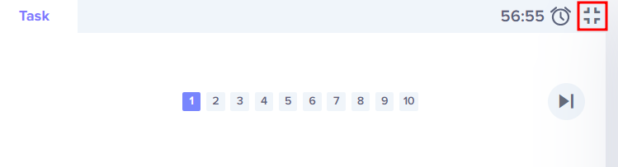

Solutions:-

🖥️ Step 1: Log in
- Go to AWS Console Login.
- Enter:
  - Username: kk_labs_user_351802
  - Password: 5TT7BOhOLoLM
- Confirm you’re in us-east-1 (N. Virginia) region.

⚙️ Step 2: Launch EC2 Instance
- Navigate to EC2 → Instances → Launch Instance.
- Name: Enter nautilus-ec2.
- AMI: Select Ubuntu Server 20.04 LTS (Free tier eligible).
- Instance type: Choose t2.micro.
- Key pair: Select an existing key pair or create a new one (needed for SSH).
- Network settings:
  - Choose default VPC and subnet.
  - Enable Auto-assign Public IP (optional since we’ll attach Elastic IP).
  - Add security group rules:
    - SSH (port 22) for admin access.
    - HTTP (port 80) / HTTPS (port 443) if hosting a web app.
- Storage: Leave default (8 GB gp2).
- Click Launch Instance.

🌐 Step 3: Allocate Elastic IP
- In the EC2 dashboard, go to Elastic IPs (left menu).
- Click Allocate Elastic IP address.
- Choose Amazon’s pool of IPv4 addresses.
- Click Allocate.
- After allocation, select the Elastic IP → Actions → Manage Tags → Add tag:
  - Key: Name
  - Value: nautilus-eip

🔗 Step 4: Associate Elastic IP
- Select the Elastic IP you just created.
- Click Actions → Associate Elastic IP address.
- Choose:
  - Instance: Select nautilus-ec2.
  - Private IP address: Leave default.
- Click Associate.

✅ Verification
- Go back to Instances → Select nautilus-ec2.
- Under Networking tab, confirm the Elastic IP is attached.
- You can now use this IP to access your hosted application reliably.
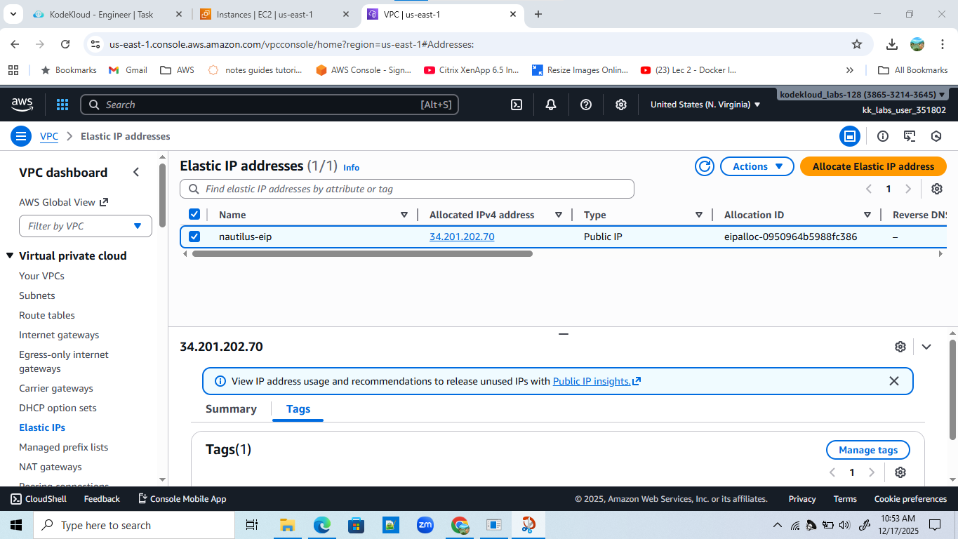s

